DATABASE MANAGEMENT SYSTEMS (ITCO8)

PRACTICAL FILE



**NAME:** JAHANAVI MISHRA

**ROLL NO:** 2017UIT2622

**BRANCH:** INFORMATION TECHNOLOGY

**SECTION:** 2

**SUBMITTED TO:** PROF. VIKAS MAHESHKAR

**INDEX**

|  |  |
| --- | --- |
| **S.NO** | **PROBLEM** |
| **1** | Flights(flno, from, to, distance, departs) Aircraft(aid, aname, range) Certified(eid, aid) Employees(eid, ename, salary) |
| **2** | Author ( authorname, citizenship, birthyear) Book(isbn, title, authorname) Topic(isbn, subject) Branch(libname, city) Instock(isbn, libname, quantity) |
| **3** | Suppliers( sid: integer ,sname:varchar(10),address: varchar(10),) Parts( pid: integer , pname: varchar(10), color: varchar(10)) Catalog( sid: integer, pid: integer , cost: real) |

**Create database and write SQL queries for the following:**

**Q1. Flights(flno, from, to, distance, departs)**

**Aircraft(aid, aname, range)**

**Certified(eid, aid)**

**Employees(eid, ename, salary)**

**By definition, pilots are those employees who are certified on at least one aircraft. An aircraft can be used for any flight provided it has sufficient range. Pilots can pilot any flight provided they are certified on an aircraft with sufficient range.**

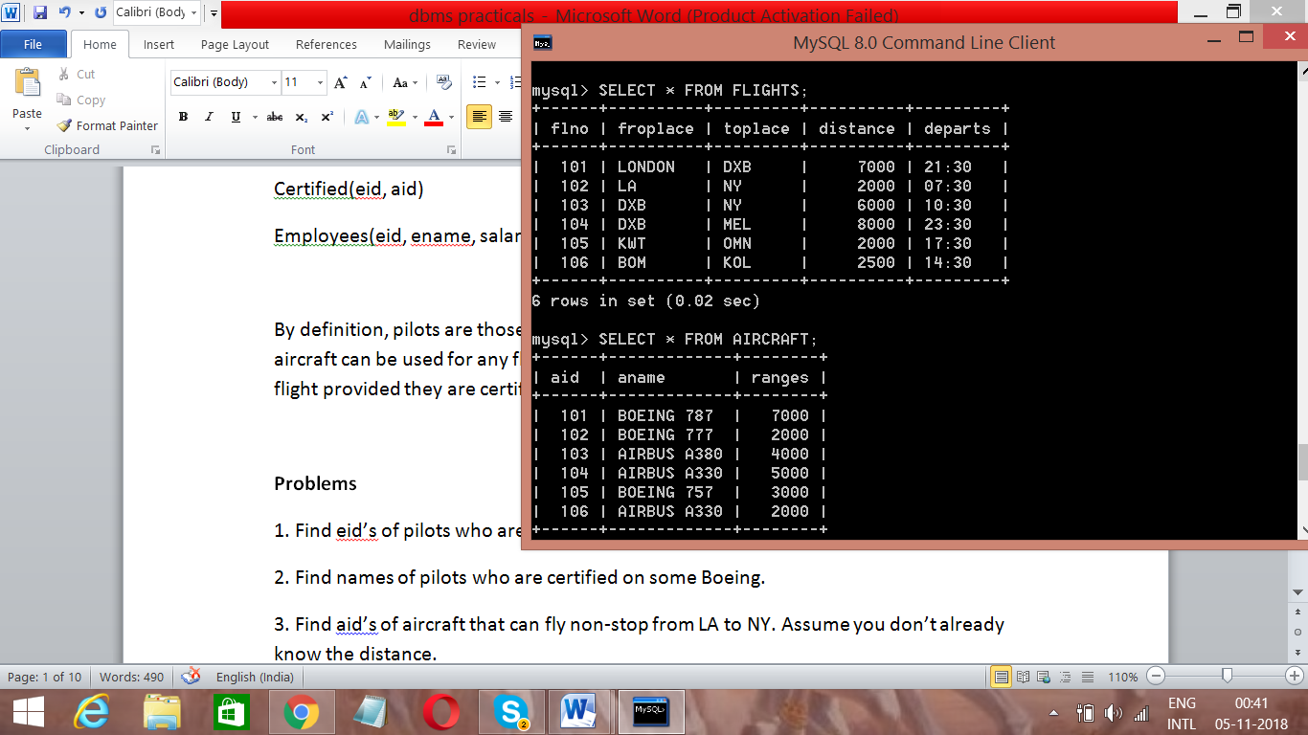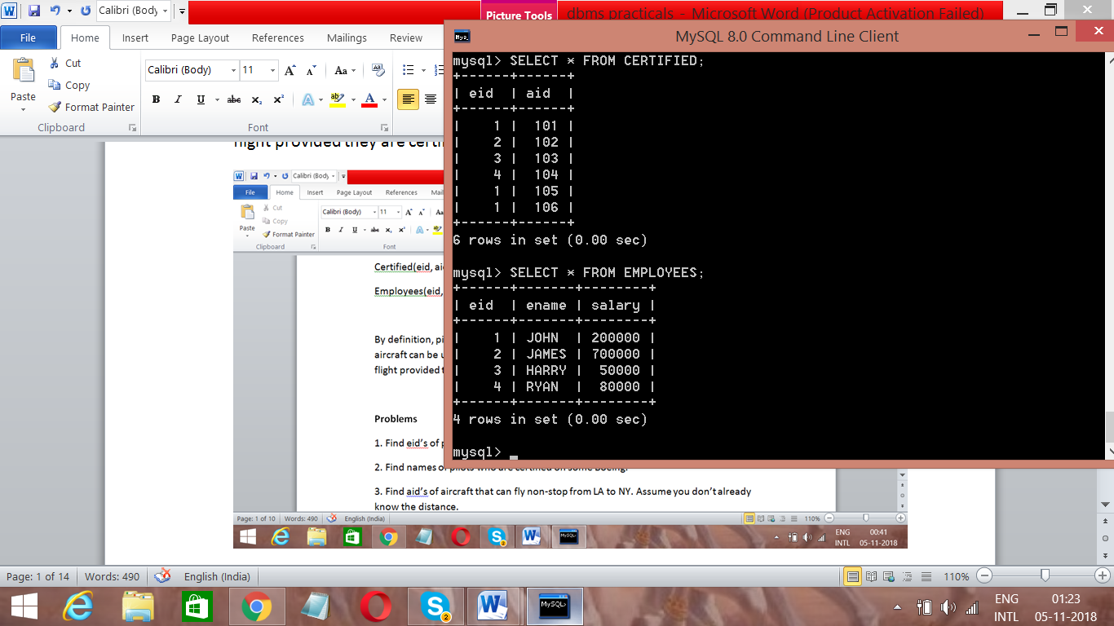

**Problems**

1. Find eid’s of pilots who are certified on some Boeing.

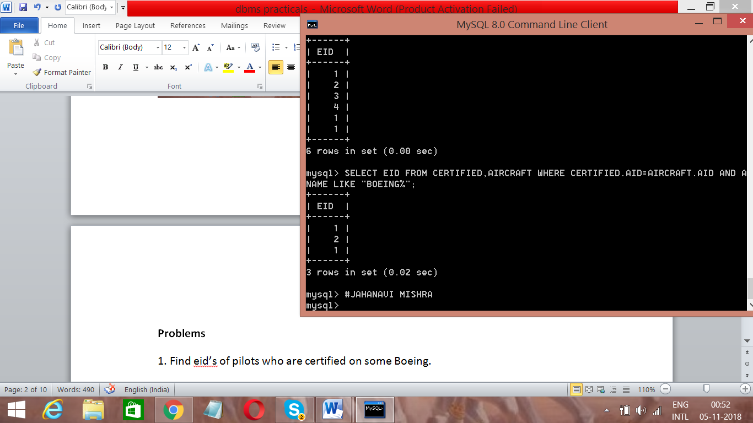

1. Find names of pilots who are certified on some Boeing.

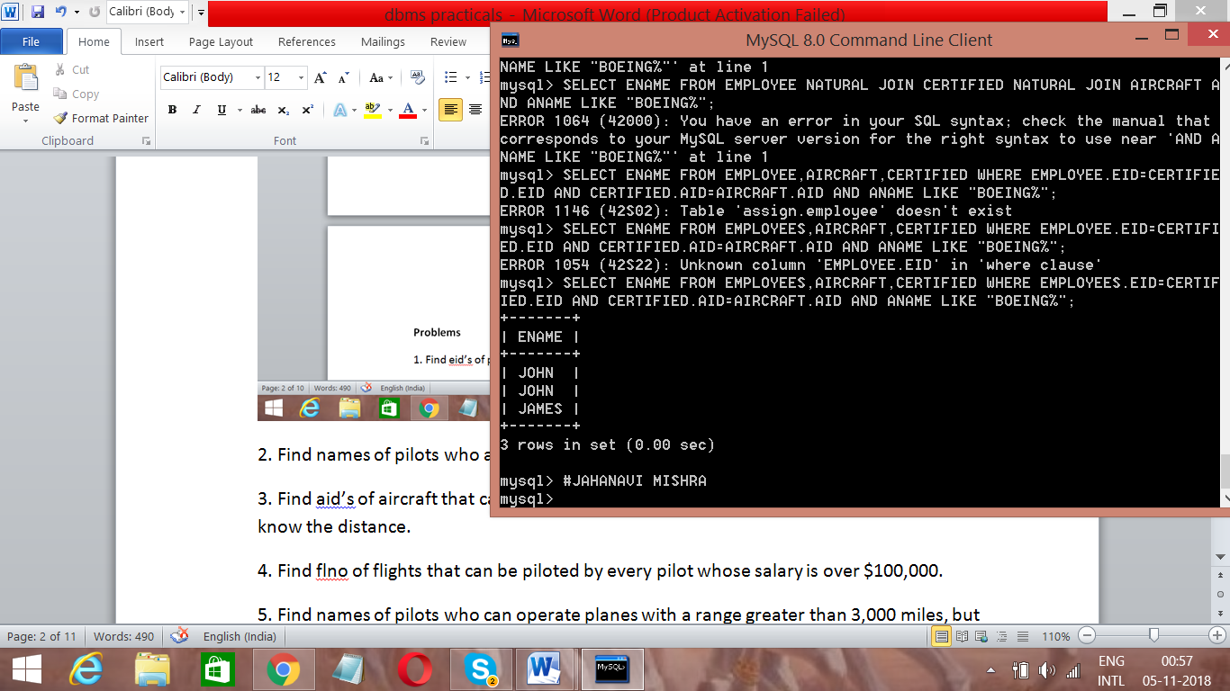

1. Find aid’s of aircraft that can fly non-stop from LA to NY. Assume you don’t already know the distance.

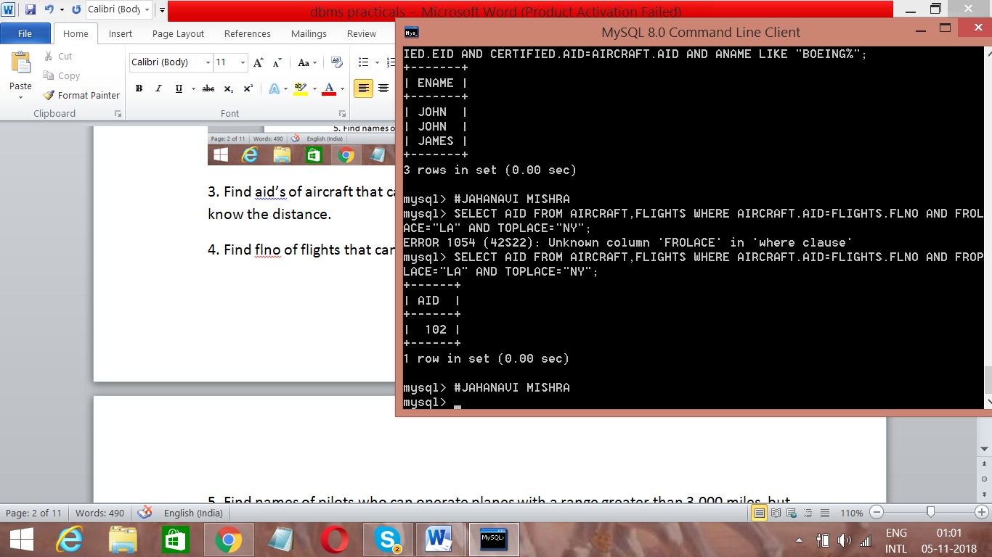

4. Find flno of flights that can be piloted by every pilot whose salary is over $100,000.

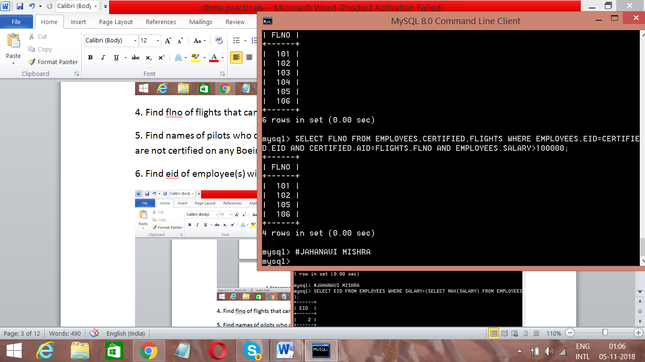

5. Find names of pilots who can operate planes with a range greater than 3,000 miles, but are not certified on any Boeing.

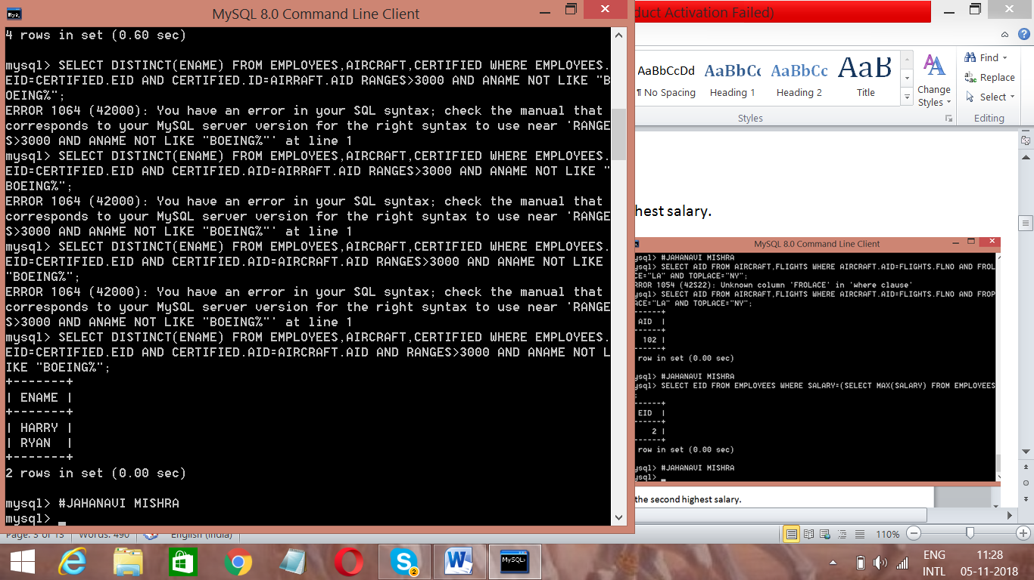

6. Find eid of employee(s) with the highest salary.

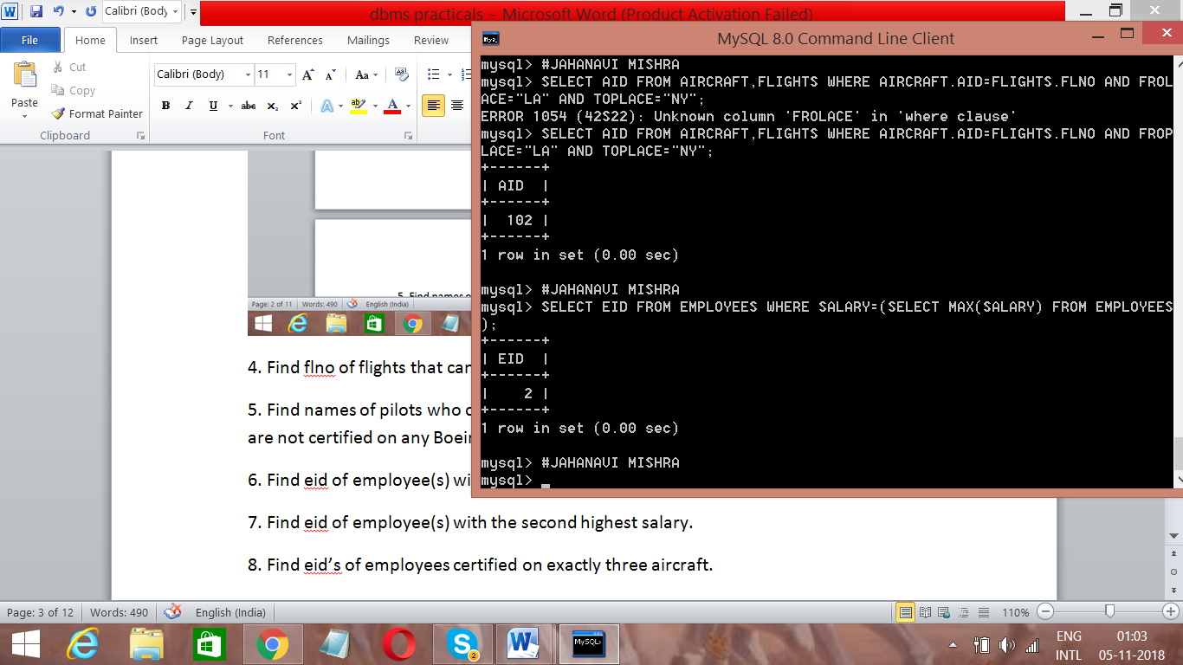

7. Find eid of employee(s) with the second highest salary.

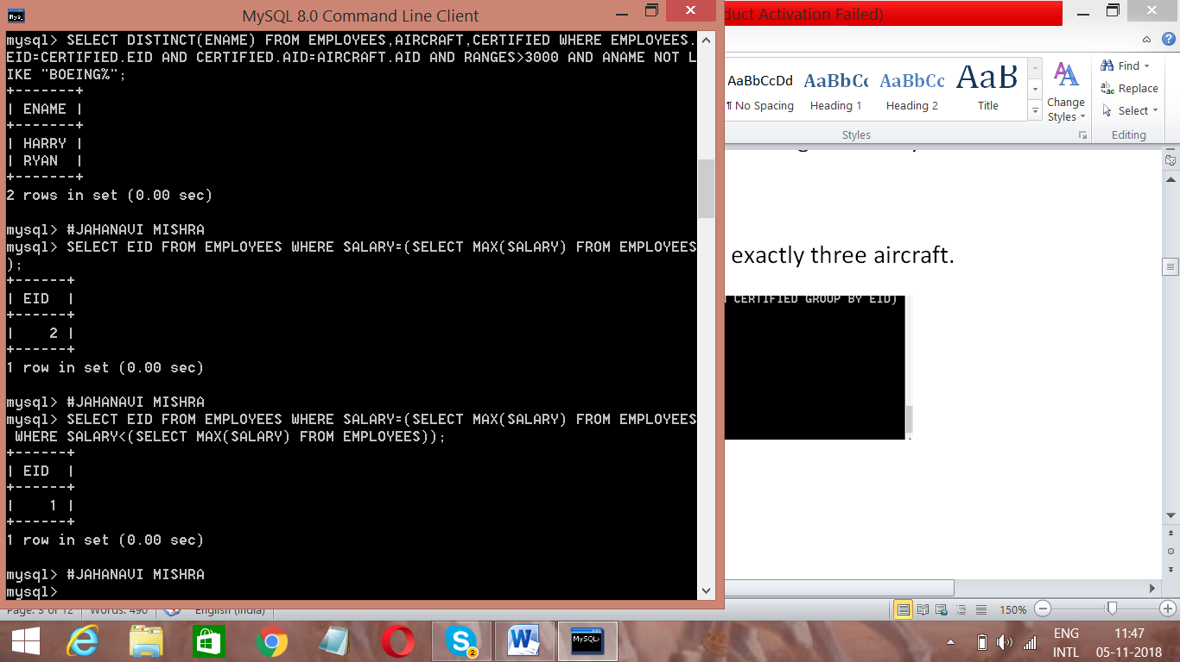

8. Find eid’s of employees certified on exactly three aircraft.

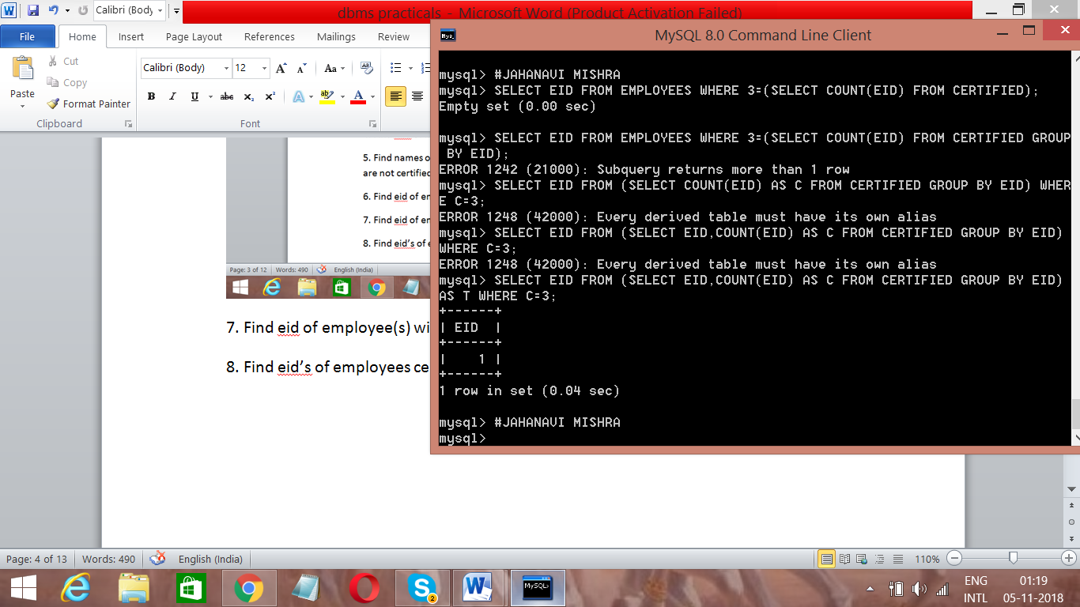

Q2. **Author ( authorname, citizenship, birthyear)**

**Book(isbn, title, authorname)**

**Topic(isbn, subject)**

**Branch(libname, city)**

**Instock(isbn, libname, quantity)**

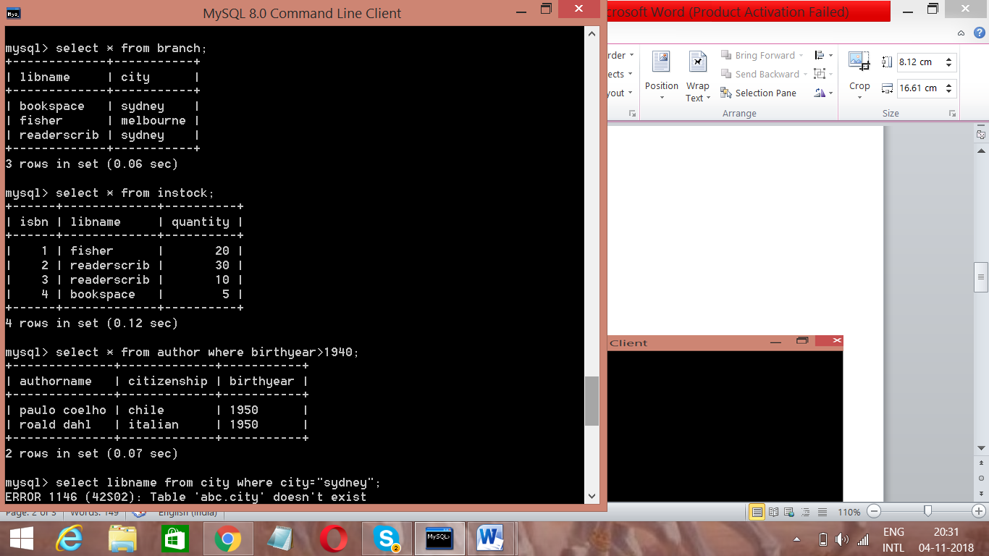

1. Give all authors born after 1940.

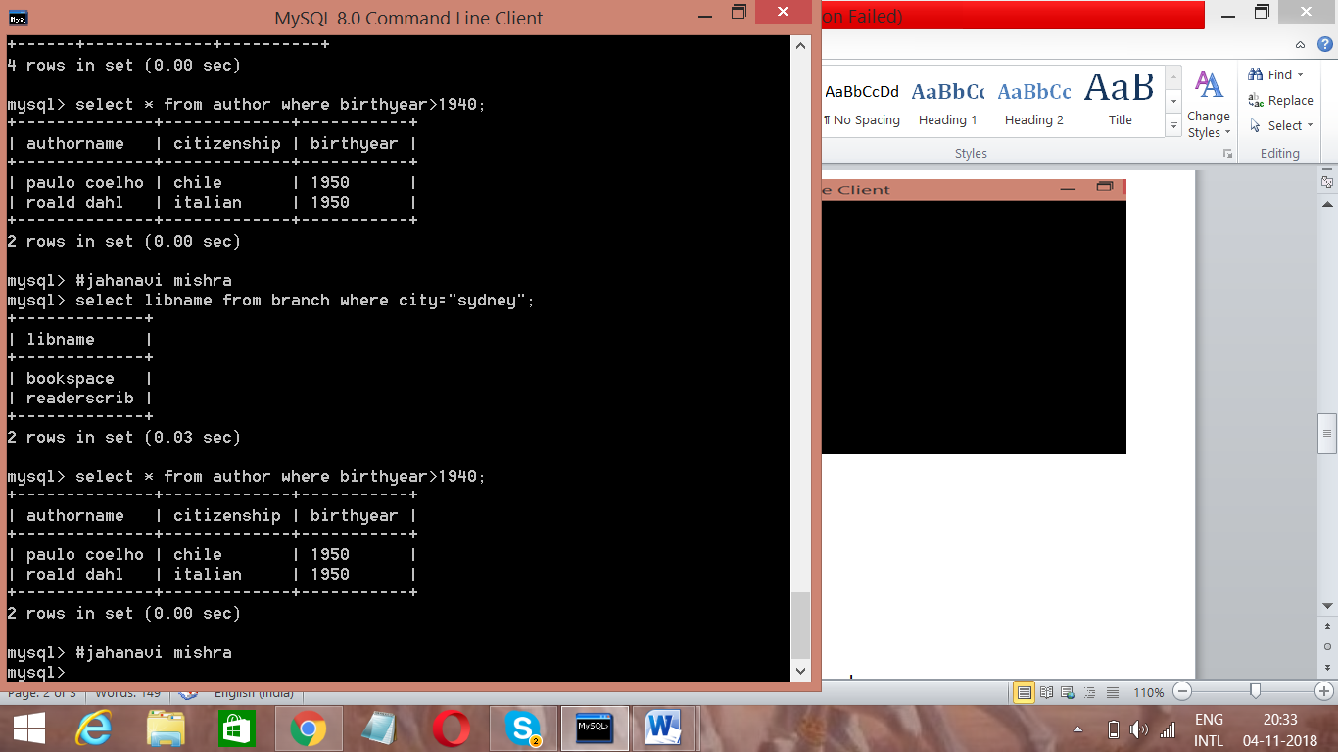

1. Give the names of libraries in Sydney.



1. Give the cities where each book is held.

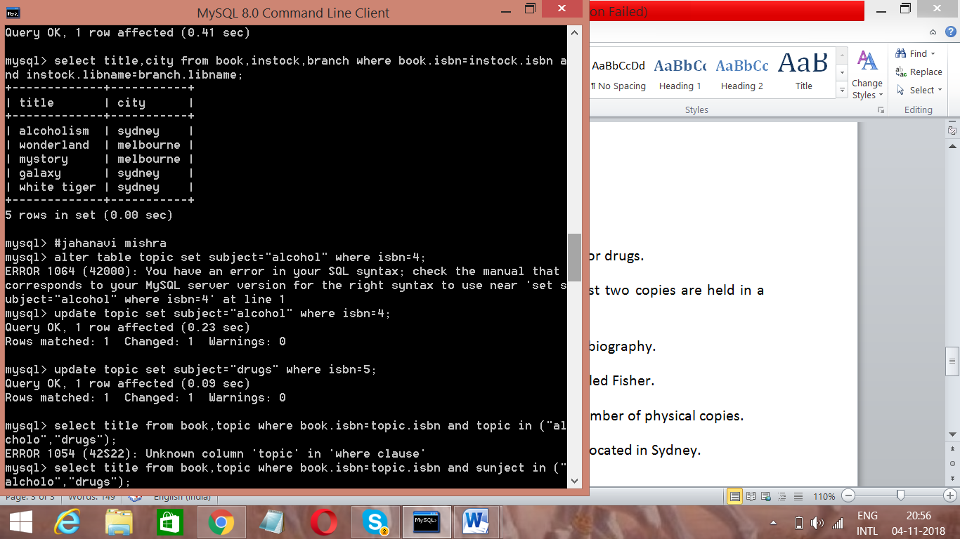

4. Give the title of each book on the topic of either alcohol or drugs.

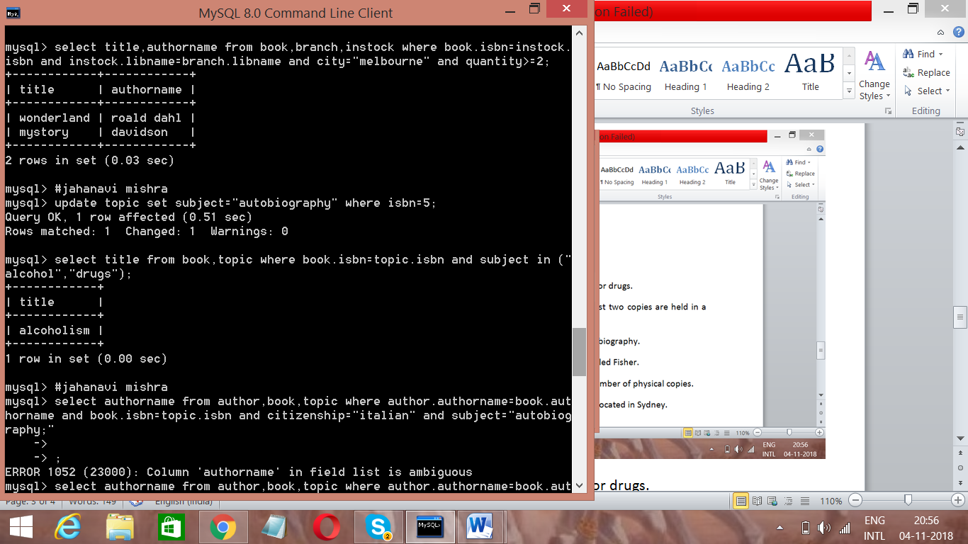

5 Give the title and author of each book of which at least two copies are held in a branch located in Melbourne.



6. Give the name of each Italian author who wrote an autobiography.



7. Give the total number of books in stock in the branch called Fisher.This could mean the number of different titles, or the number of physical copies.



8. Give the total number of books in stock in the branches located in Sydney.

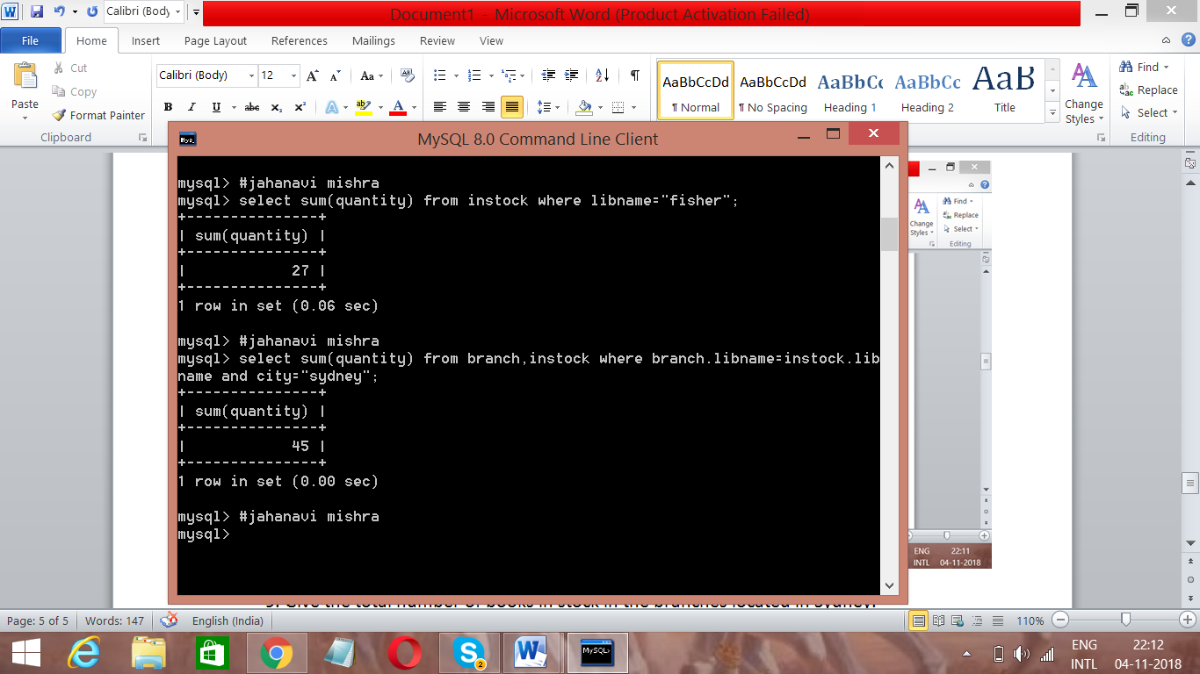

Q3. Consider a database:

**Suppliers(*sid: integer,sname:varchar(10),address: varchar(10),)***

**Parts(*pid: integer, pname: varchar(10), color: varchar(10))***

**Catalog(*sid: integer, pid: integer, cost: real)***

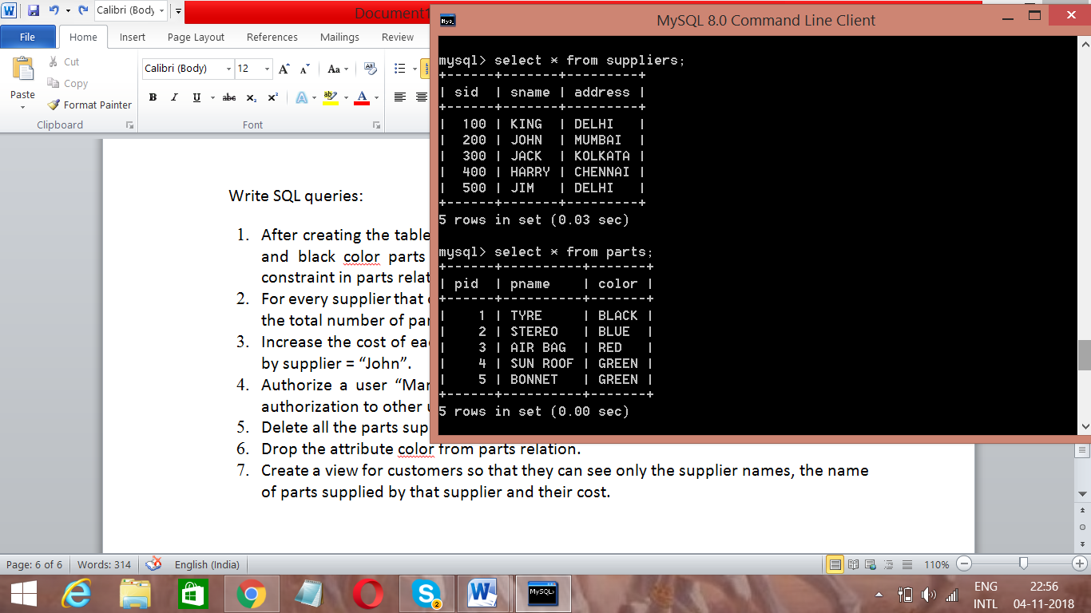 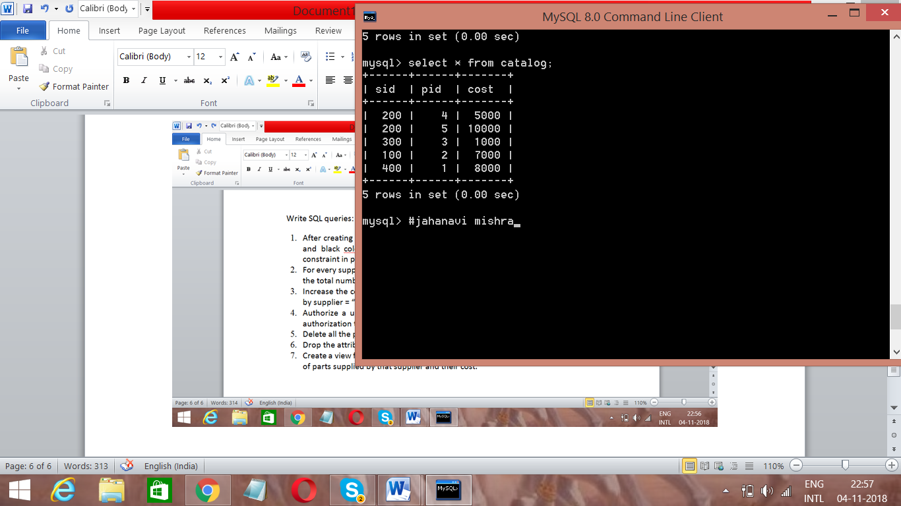

Write SQL queries:

1. After creating the table I realized that I forgot to mention that only green, red, blue and black color parts are allowed in parts relation. Write a query to add this constraint in parts relation.

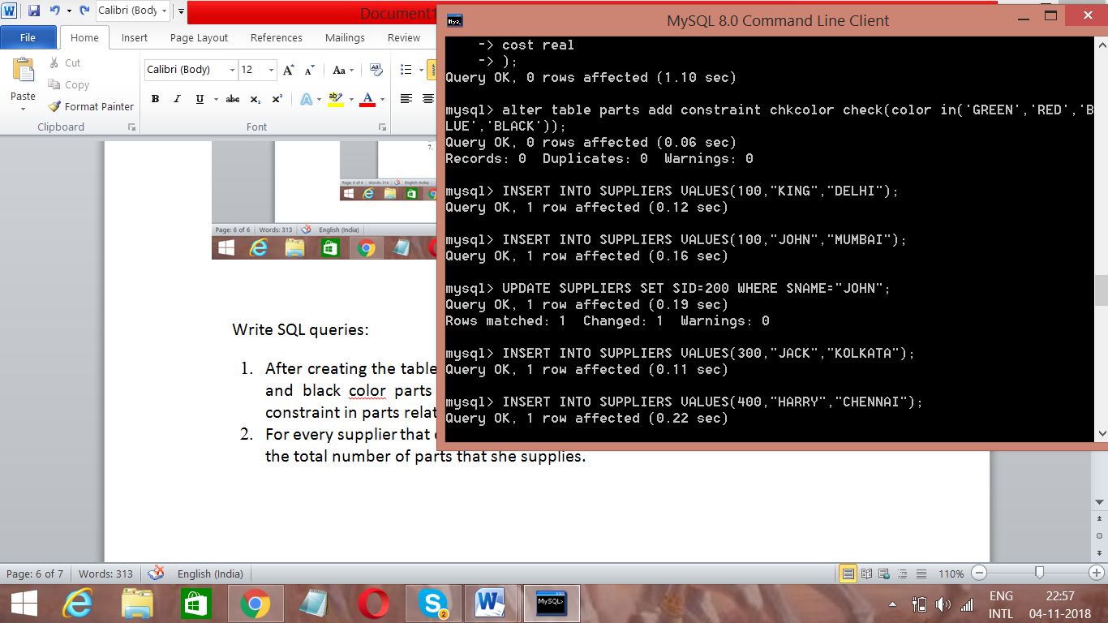

1. For every supplier that only supplies green parts, print the name of the supplier and the total number of parts that she supplies.



1. Increase the cost of each product by 10% which are green in color and are supplied by supplier = “John”.

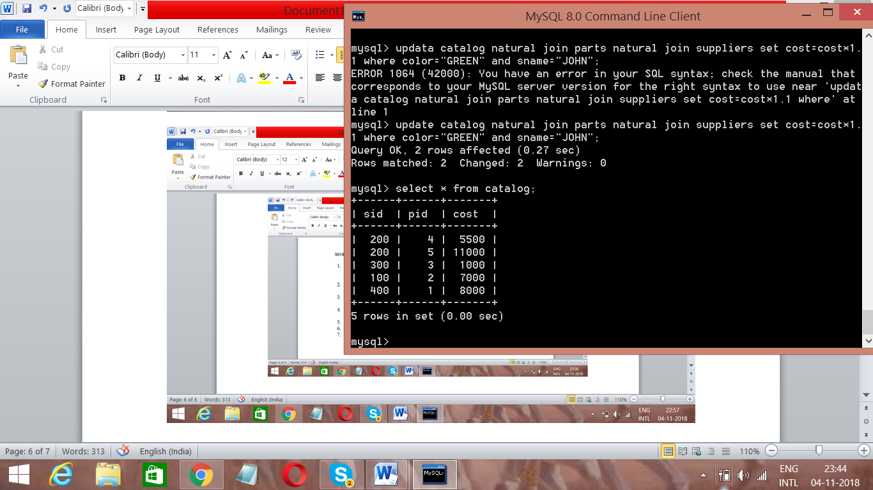

1. Delete all the parts supplied by supplier “King”. 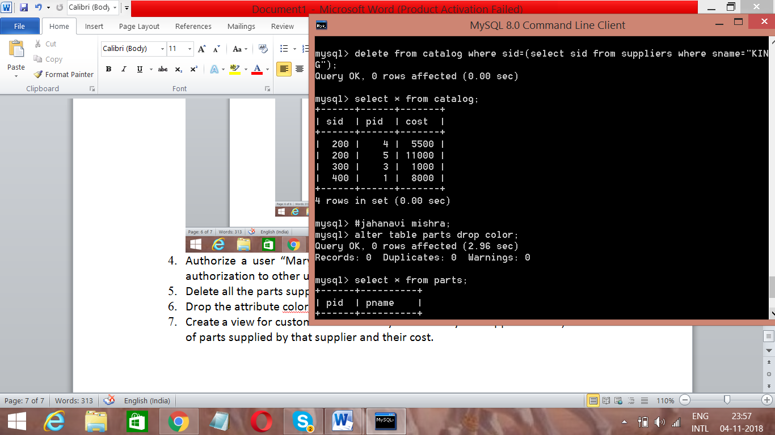
2. Drop the attribute color from parts relation. 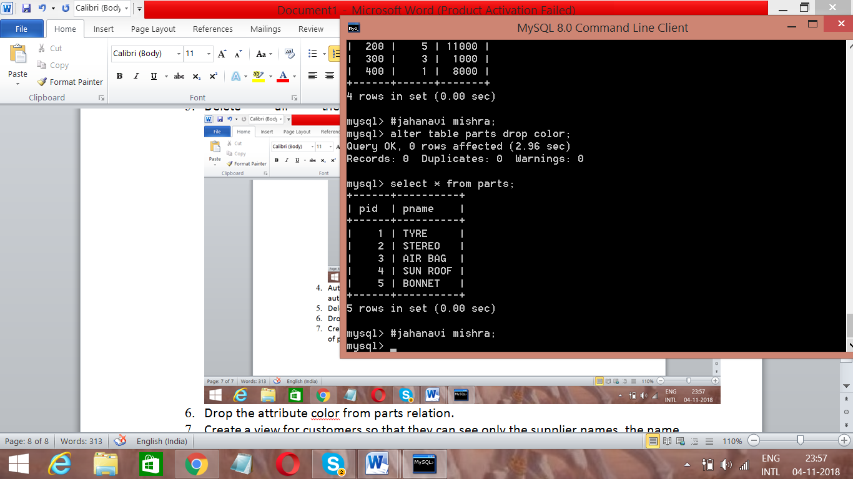
3. Create a view for customers so that they can see only the supplier names, the name of parts supplied by that supplier and their cost.

